Lesson Plan #1- History of Floyd Bennett Field

Time Frame: 45 minutes

Aim: How has Floyd Bennett Field evolved over the last century?

Instructional Objectives:

Students Will Be Able To: (SWABT)

- Timeline the evolution of FBF from Barren Island to a municipal airport, Naval base, and eventually national park.

- Explain the factors, which change places over time, and apply them to FBF.

- Correlate the impact of technology on the development of land.

Standards: Common Core (as listed in the NYCDOE websites)

ELA standards for grades 6-12)

College and Career Readiness Anchor Standards for Reading: 1, 2,3,4,7,8,9,11

Reading Standards for Informational Text 6-12: 1,2,3,4, 7,8,9

College and Career Readiness Anchor Standards for Writing: 1,2,3,4,5,6,8,9,10, 11

College and Career Readiness Anchor Standards for Speaking and Listening: 1,2,3,4,5,6

College and Career Readiness Anchor Standards for Language: 1,2,3,4,6

­Standards for Literacy in History/Social Studies, Science, and Technical Subjects 6-12

College and Career Readiness Anchor Standards for reading: 1,2,3,4,5,6,7,8,10

College and Career Readiness Anchor Standards for Writing: 1,2,3,4,5,7,8,9

College and Career Readiness Anchor Standards for Speaking and Listening: 1,2,3,4,5,6

Historical Information for teachers:

What eventually became the bustling air transit hub of Floyd Bennett field started out more modestly as an uninviting strip of coastal beach called Barren, Island. As recent as 1762, this swath of sand and scattered trees had been described by observers as a “vacant and unoccupied,” wasteland.[1] It was not until around 1800, that the first permanent settlements would be constructed on the island. This included an inn and the family dwelling of the island’s leading family, the Dooly’s. The island, initially was too far from Manhattan to benefit from the early commercial activity that was occurring there but close enough to the commercial shipping lanes and fisheries to serve as a stop off point for weary sailors and other seafarers. It was those seafarers that the inn would serve.

During the 1850’s, as a direct result of the industrial revolution, Barren Island would see its first period of major growth and development, becoming a city leader in the “odorous” animal-processing field.[2] The island because of its distance and isolation from great population centers was seen as an ideal place for both horse rendering and fish waste product manufacturing. It was located on shipping lanes, which was good logistically and the ocean provided a disposal ground for factory and animal waste. Waste processing, (both human and animal) and fertilizer manufacturing became the islands biggest industries and brought people to the area.

Yet by 1900, there were still only 520 residents inhabiting the island. It took another 30 years for the area to begin to transition into a municipal airport. Construction began on the municipal airport in 1929. Floyd Bennett Field had been conceived as one of the most modern airports in the world. Unfortunately, construction coincided with the Great Depression and although, the WPA undertook some of the labor, the stagnant economy hurt the chances of successfully developing a municipal airport at Floyd Bennett Field.

Barren Island was expanded by landfill to support the runways and hangars that the mass undertaking required. The facility was designed to accommodate both land and sea planes. Following its dedication on May 23, 1931, it immediately became one of the most popular sites for early aviators, hosting many record setting flights and multiple competitions.

Despite it being a favorite of many aviators, the concept of it becoming a major municipal airport failed to materialize as Floyd Bennett Field lost out to Newark airport for the U.S. mail contract and with the construction of LaGuardia airport in northern Queens it could no longer survive commercially. In 1941, Floyd Bennett Field became U.S. Naval Air Station-New York. During WWII it became an important domestic naval base for training pilots, ferrying aircraft, and protecting the NYC metropolitan area.

It remained a naval base during the Cold War until 1971, when it was deactivated, after which it was transferred over to the National Parks Service as a piece of Gateway National Recreation Area. Today it serves the New York City community as both a historical site and leisure park.

This lesson is meant to showcase how this area transitioned from that provincial outpost to a manufacturing center, and then eventually an airport, military base, and national park. The juxtaposition of Manhattan and Floyd Bennett Field is a relevant one because their development is so closely related.

Do Now/Motivation: (5 min) Write down an example of a place in your neighborhood that has changed in your lifetime. It could be big like a large building or small like a city corner, as long as it has changed physically. *Once students have shared out their examples prompt them into examining why these changes have occurred. (Example explanations: Profitability, opportunity, population increase, change in ownership, etc.…)*

Agenda:

Activity 1: (10 min) Show students a series of three slides that span the development of lower Manhattan, and ask them to determine in their opinion, what is the cause of the dramatic change?

*The procedure should progress as follows: While showing the first slide state, “Let me show you a picture of NYC. When do you think this picture was made?” Have students gauge their answers based on their knowledge of history and NYC the origin, era, and subject of the picture. Move on to the second slide.*

*While showing the second slide ask, “This is a picture of NYC, when was it made? How does this picture compare to the first?” Once again have students determine the origin of the picture, but also compare and contrast it to the original. Try and challenge the students to determine what occurred in NYC to account for this change in scenery. Move on to the third slide.*

*While showing the third slide ask again, “This is a picture of NYC, when was it made? How does this picture compare to the first two pictures?” Have students compare and contrast the three pictures and conclude the activity by posing the question, “Using your knowledge of history, what has happened to NYC since 1876, when the first picture was made, to account for these sweeping changes?” Students using prior knowledge or intuition should be able to generate some ideas i.e., technology, immigration, conflict, etc., that account for the physical change of places and things. These ideas can later be projected on FBF. To enhance activity, make a Venn Diagram (NYC then and now) on the board.*

Photo 1) Lower Manhattan 1876

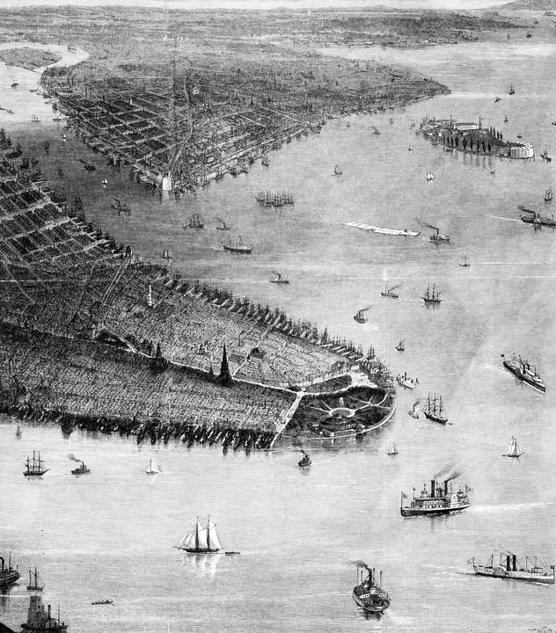

Photo 2) Lower Manhattan 1929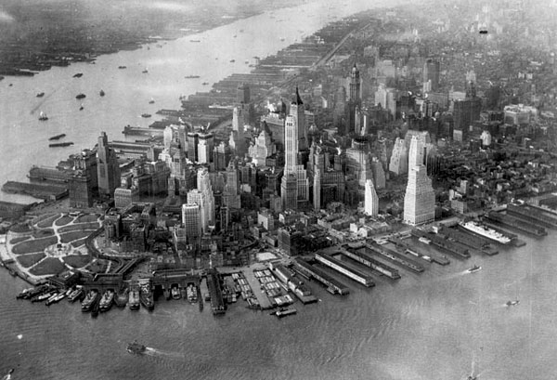

Photo 3) Lower Manhattan 2008

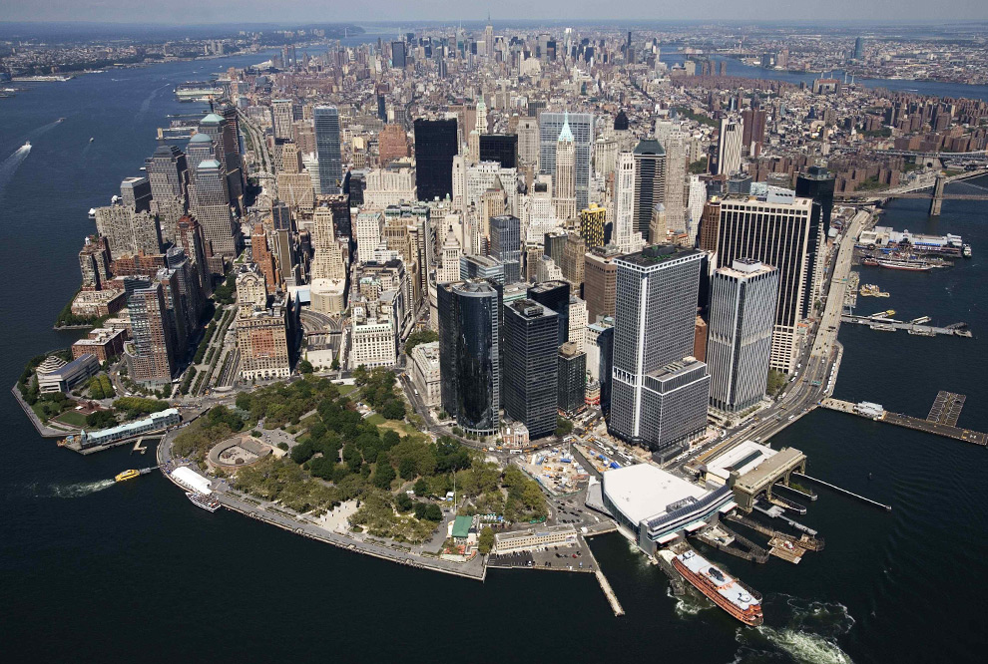

Photo 4) Venn Diagram Template

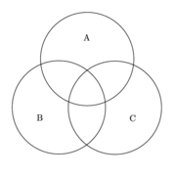

*Example Venn Diagram Format*

*Category A- What is unique to Photo 1?*

*Category B- What is unique to Photo 2?*

*Category C- What is unique to Photo 3?*

*Overlapping Space- What is similar in the photos?*

Activity 2: (25 min) Composite question: Break up class into groups of 3-5, and distribute seven FBF photographs with dates to each group. While groups are looking over photographs and putting them in chronological order, the timeline below will be projected on the overhead. *Now pose the question, “Here are pictures of FBF, which is located on southeast end of NYC. How do these pictures of change compare to those of lower Manhattan? What has happened to the landscape and why?”*

Provide each group three prompts to assist them in their photo comparison. *Prompts can be distributed as a handout, written in their notebooks, or projected/written on the board.*

1. “How has the land evolved in the time frame we are looking at?”
2. “What do you think is the reason for these changes?”
3. “ Write down any details and differences that will help you in answering the first two questions.”

While students put the photos in order and answer the prompts, assist them as needed.

Circulate the room and try and prompt students to make connections between the development of NYC, Floyd Bennett Field, and the timeline. Have students compare the dates on the photos and the dates in the timeline. After due time is given reconvene the class and have students share out their findings and conclusions, while going over the questions.

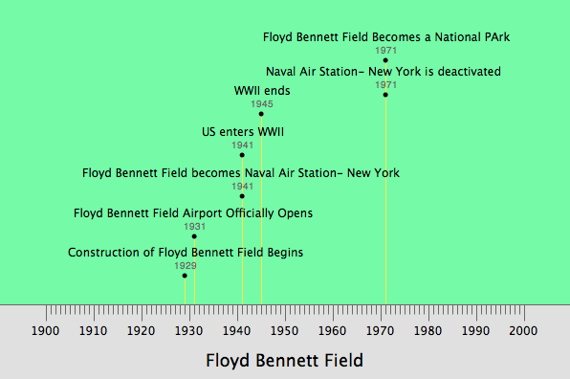

FBF 1924, Photo 5) “The Vast Wasteland”

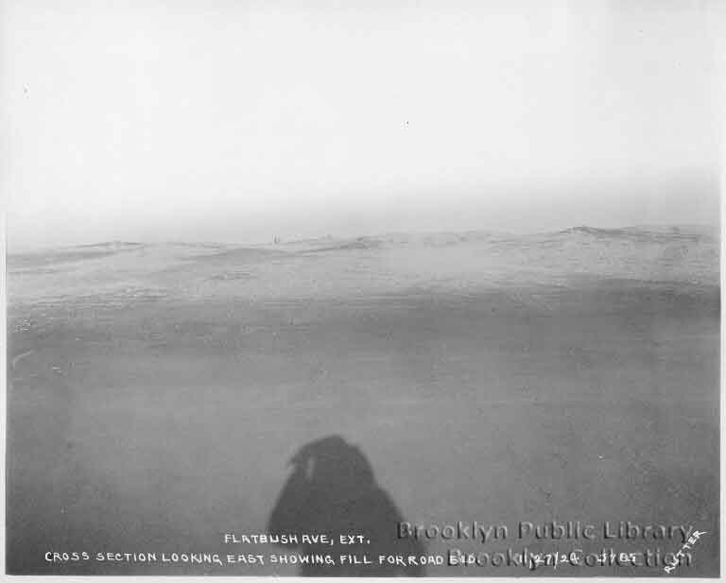

FBF 1931, Photo 6) “A Plane in the Distance”

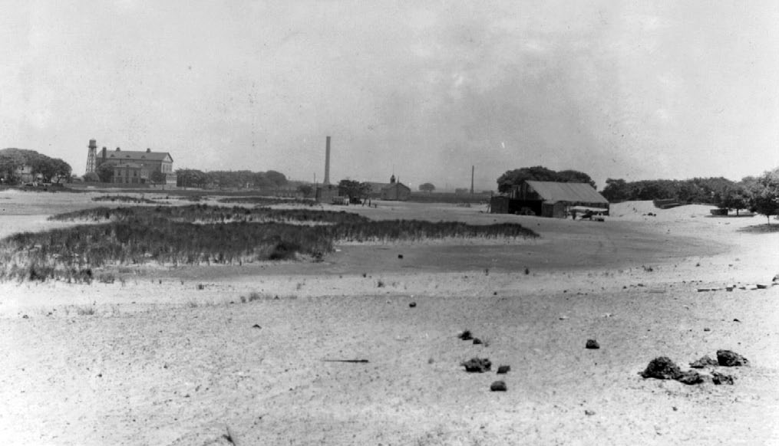

FBF 1942, Photo 7) “Construction of a Naval Base”

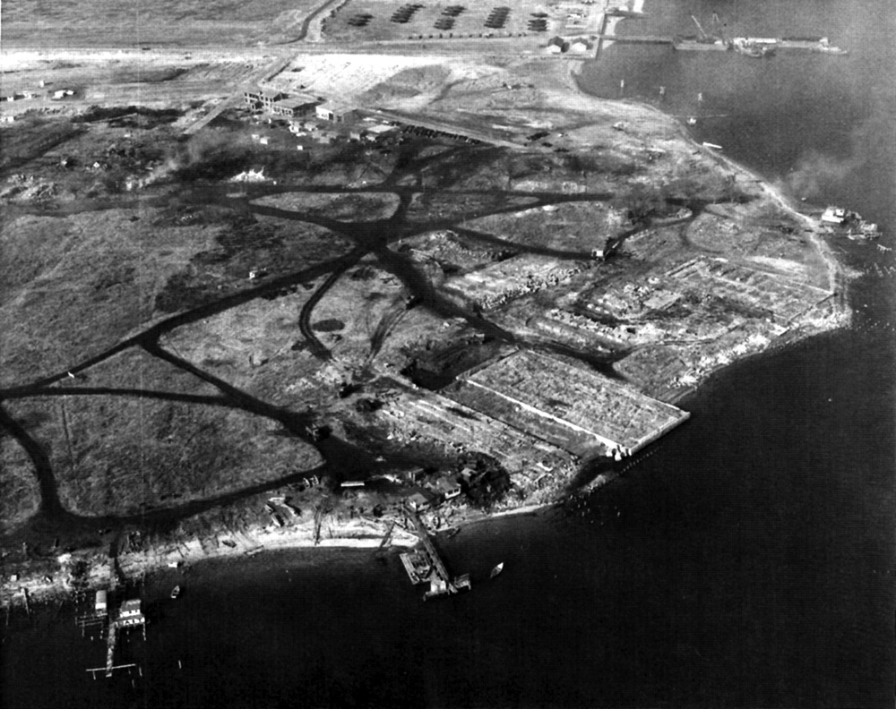

FBF, 1943 Photo 8) “Naval Base after Completion”

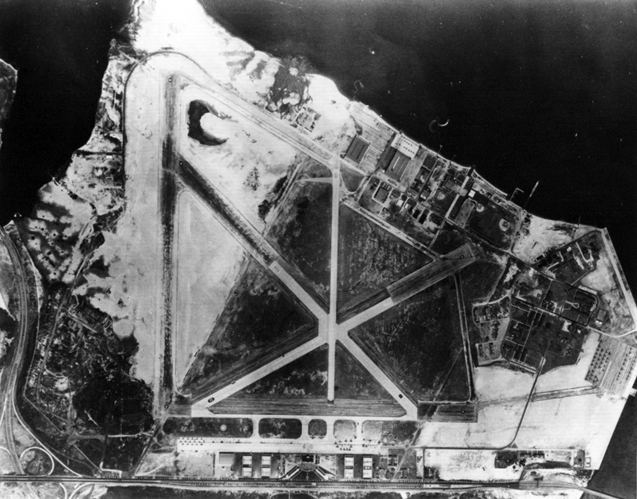

FBF, 1960 Photo 9) “Protecting the Coastline”

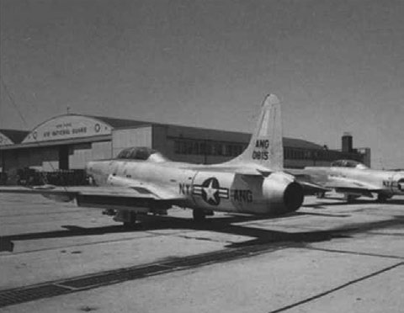

FBF, 1975 Photo 10) “An Urban Campground”

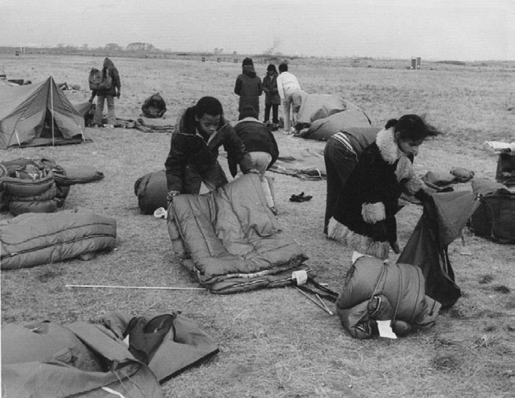

Exit Assessment: (5 min) Have students write out exit slips, which can be collected. Based upon what we learned today about the development of NYC and FBF, what role has technology played in the development of these two areas?

Homework Assignment: Make a prediction about the future. Youths are more in tune to technology than most adults and often are the ones who introduce their elders to the latest technologies. Using the development of Floyd Bennett Field and NYC as a reference, how do you think your neighborhood will change over the next 50 to 100 years? Give specific examples of at least 2 changes that you’d like to see occur in this time frame to your neighborhood as a result of technology.

1. Where is your neighborhood?
2. What changes would you like to see to your neighborhood in the next 50 to 100 years as a result of technology?
3. How would these changes benefit your neighbors and yourself?

|  |  |  |
| --- | --- | --- |
| **Exceeds Expectations** | **Meet Expectations** | **Does not meet expectations** |
|  |  |  |
| Group Work Rubric | | | |
| Completely addresses all prompts. | Addresses the majority of prompts. | Failed to address the prompts. |
| Demonstrated excellent teamwork and cooperation. | Generally stayed on task during cooperative work. | Were disruptive and worked poorly together as a team. |
| Excellent logic and usage of class materials and concepts. | Few errors of logic and some misunderstanding of terminology. | Little understanding of class materials and concepts. |
|  |  |  |
| Class Participation Rubric | | | |
| Asks interesting questions. | Asks an occasional question. | Never asks a question. |
| Responds to teacher question in a thought provoking way. | Responds to question. | Does not respond to teacher question. |

Photo/ Image Bibliography:

1) Lower Manhattan 1876

(<https://ldpd.lamp.columbia.edu/omeka/items/show/2861>)

2) Lower Manhattan 1929 (<http://wirednewyork.com/forum/showthread.php?t=5399&page=1>)

3) Lower Manhattan 2008

(<http://www.boston.com/bigpicture/2008/09/seven_years_since_looking_back.html>)

4) Venn Diagram

(<http://images-mediawiki-sites.thefullwiki.org/08/2/8/7/41442844032698403.png>)

5) FBF 1924

(<http://catalog.brooklynpubliclibrary.org/articles/11090551.4168/1.JPEG>)

6) FBF 1931

P.34 Cultural Landscape Report

7) FBF 1942

P. 120 Cultural Landscape Report

8) FBF 1943

P. 109 Cultural Landscape Report

9) FBF 1960

P. 145 Cultural Landscape Report

10) FBF 1975

P. 172 Cultural Landscape Report

Submitted by Frank Cafarella

Brooklyn College

Graduate Student Intern

Summer 2011

1. P.23 Cultural Landscape Report
2. p. 25 Cultural Landscape Report